1. Java string program to print even-length words

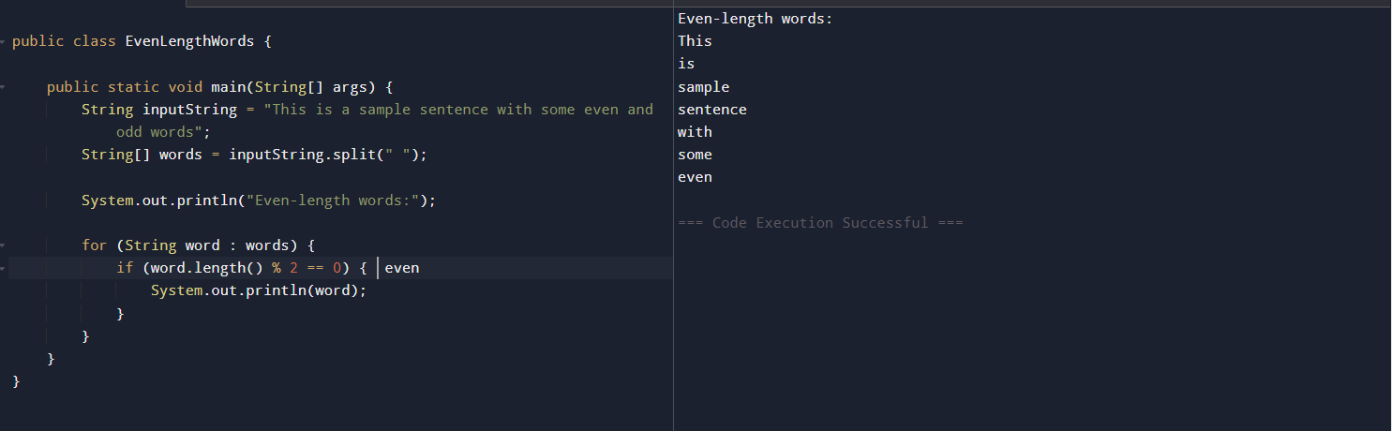

1. Java string program to insert a string into another string

public class InsertExample {

public static void main(String[] args) {

String text = "abc";

String insert = "XYZ";

int position = 1;

String result = text.substring(0, position) + insert + text.substring(position);

System.out.println(result);

}

}

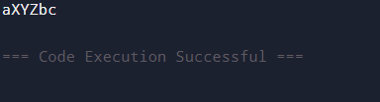

1. Java string program to check whether a string is a Palindrome

public class PalindromeShort {

public static boolean isPalindrome(String str) {

str = str.replaceAll("[^a-zA-Z0-9]", "").toLowerCase();

for (int i = 0; i < str.length() / 2; i++) {

if (str.charAt(i) != str.charAt(str.length() - 1 - i)) return false;

}

return true;

}

public static void main(String[] args) {

System.out.println(isPalindrome("madam"));

System.out.println(isPalindrome("hello"));

}

}

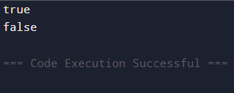

1. Java string program to check anagram

import java.util.Arrays;

public class AnagramShort {

public static boolean areAnagrams(String s1, String s2) {

s1 = s1.replaceAll("\\s", "").toLowerCase();

s2 = s2.replaceAll("\\s", "").toLowerCase();

if (s1.length() != s2.length()) return false;

char[] c1 = s1.toCharArray();

char[] c2 = s2.toCharArray();

Arrays.sort(c1);

Arrays.sort(c2);

return Arrays.equals(c1, c2);

}

public static void main(String[] args) {

System.out.println(areAnagrams("listen", "silent"));

System.out.println(areAnagrams("hello", "world"));

}

}

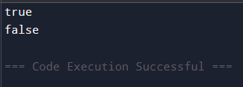

5.Java string program to reverse a string

public class ReverseString {

public static String reverseString(String input) {

StringBuilder reversed = new StringBuilder();

for (int i = input.length() - 1; i >= 0; i--) {

reversed.append(input.charAt(i));

}

return reversed.toString();

}

public static void main(String[] args) {

String original = "Hello, world!";

String reversed = reverseString(original);

System.out.println("Original: " + original);

System.out.println("Reversed: " + reversed);

}

}

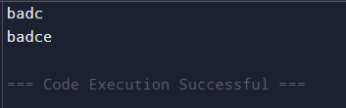 6. java string program to swapping pair of characters

public class SwapPairsShort {

public static String swapPairs(String s) {

if (s == null || s.length() < 2) return s;

StringBuilder sb = new StringBuilder();

for (int i = 0; i < s.length() - 1; i += 2) {

sb.append(s.charAt(i + 1)).append(s.charAt(i));

}

return s.length() % 2 == 0 ? sb.toString() : sb.append(s.charAt(s.length() - 1)).toString();

}

public static void main(String[] args) {

System.out.println(swapPairs("abcd"));

System.out.println(swapPairs("abcde"));

}

}

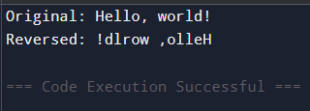

7. Java string program to replace a character at a specific index

public class ReplaceCharAtIndex {

public static String replaceChar(String str, int index, char newChar) {

if (str == null || index < 0 || index >= str.length()) {

return str;

}

StringBuilder sb = new StringBuilder(str);

sb.setCharAt(index, newChar);

return sb.toString();

}

public static void main(String[] args) {

String original = "Hello";

String replaced = replaceChar(original, 1, 'a');

System.out.println("Original: " + original);

System.out.println("Replaced: " + replaced);

String original2 = "world";

String replaced2 = replaceChar(original2, 4, 'd'); with d.

System.out.println("Original: " + original2);

System.out.println("Replaced: " + replaced2);

}

}

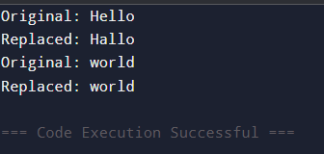

8. Java string program to remove leading zeros

public class RemoveZerosShort {

public static String removeZeros(String s) {

if (s == null || s.isEmpty()) return s;

int i = 0;

while (i < s.length() && s.charAt(i) == '0') i++;

return i == s.length() ? "0" : s.substring(i);

}

public static void main(String[] args) {

System.out.println(removeZeros("0012"));

System.out.println(removeZeros("0000"));

}

}

